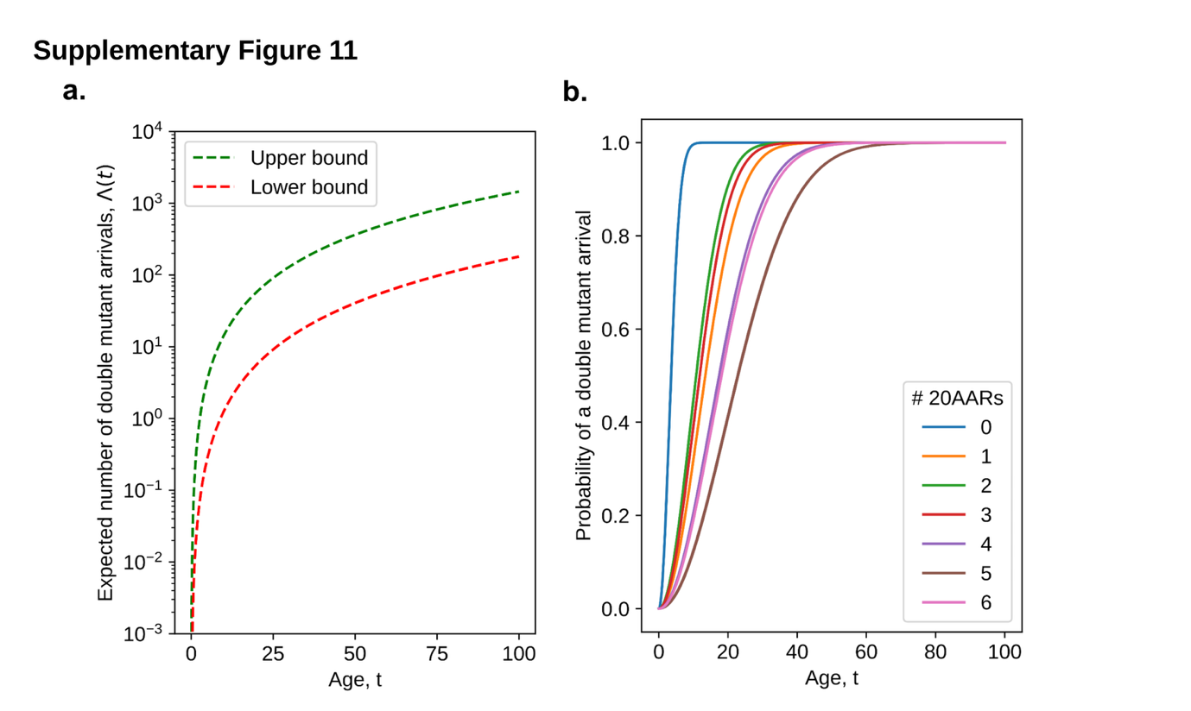Supplementary Figure 11. Arrivals of double APC mutant cells.
(a) The expected number of arrivals by a given age, $Λ(t)$, where the lower bound takes${ n}_{s}=5$ stem cells per colonic crypt and $N=10^{7}$ total crypts and the upper bound $n_{s}=7$ and $N=10^{8}$. (b) The probability of at least one arrival of a double mutant with different number of 20AARs by age t, $1-e^{-m_{X} Λ(t)}$, where $Λ(t)$ is given by Equation S3 in Supplementary Note 3 with $n_{s}=6$ and $N=5⋅10^{7}$, and $m_{X}$ is the probability of a total retaining $X$ 20AARs.

